SIMPLE INTEREST

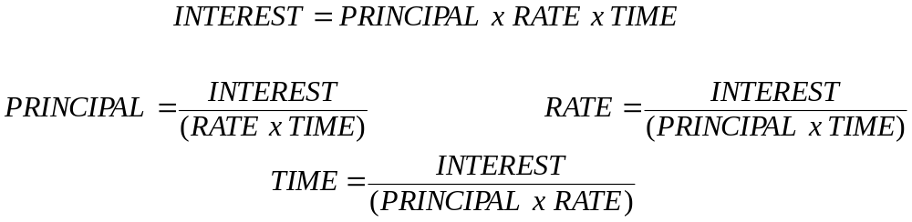

1 Find the simple interest on:

- $10000 for 1 year at 10% p.a. d) $2500 for 2 year at 10% p.a.
- $54,800 for 2 years at 20% p.a. e) $4,000 for 5 year at 20% p.a.
- $2,000,000 for 10 years at 15%

2. How much interest would be paid on a loan of $20,000 at a flat rate of 8½% p.a. over 5
years?

3. Complete

Rate | Principal | Time | Interest
11% | $1000 | 3 years | A
11% | B | 3 years | $660
11% | $1000 | C | $990
d | $2000 | 1.5 years | $300

4. Complete the following calculations
- Calculation I, given that P = $100, R = 6% and T = 3 Years
- Calculate I, given that P = $9500, R = 9.25% and T = 48 months
- Calculate I, given that P = $12,000, R = 8.75% and T = 108 months
- Calculate P, given that I = $825, R = 5% and T = 5 years
- Calculate P, given that I=$7560, R = 7% and T = 4 years

5. An investor has a spare $18,000 to lend for 2 years and hopes to earn at least $3420 in interest during that time. What is the minimum rat eof interest that needs to be charged in order to earn this amount?

6. A business has surplus cash of $9000 which is deposited in a bank that pays 8% p.a. simple interest. How long will it take the business to double their money?

Complete the table below.

Principle | Rate (%) | Time | Interest
$1500 | 10% pa | 4 years
$4200 | 12% pa | 3 years
$1800 | 8% pa | 2 years
$2500 | 15% pa | 6 years
$5000 | 8% pa |  | $800
$1000 |  | 6 | $300
 | 15% pa | 24 months | $1800
$8250 | 6% pa | 3 years
$7800 | 5% pa |  | $780
$12000 |  | 36 months | $2160
 | 8.25% pa | 48 months | $1650
$25000 | 7.5% pa |  | $937.50
$3050 |  | 8 years | $2440
 | 1% per month | 18 months | $1125
$42000 | 0.5% per month | 3 years
$120000 | 5.25% pa |  | $63000
$275000 | 8.75% pa | 12 years
$54000 |  | 96 months | $25920
 | 0.1% per week | 6 years | $9360
100 | 4% pa |  | $24

COMPOUND INTEREST

- Calculate the amount payable on a loan of $6000 at 8% compounded annually for 3 years

- Calculate the amount payable on a $20,000 loan for 3 years when the interest rate is 7% p.a. compounded annually.

- A couple deposit $13,000 in an account that pays 8% compounded annually. How much will they have in the account after 6 years?

- When you retire in 25 years time, you want to have $80,000 to live on. If your bank is currently paying 4% p.a. compounded annually and you can deposit $20,000 today. Will you have enough to live on?

- Calculate the amount payable on a loan of $1800 at 9% pa compounded half yearly for 2 years.. [Divide the rate in half 9/2 = 4.5%]

- Fred invests $25,000 for 2 years in a bank account that pays 5% compounded six monthly. How much will he receive at the end of the 2 years.

- Jaquie inherited $50,000 and she is thinking of depositing the money in a bank for 3 years while she decides what to spend it on. There are 2 banks in her town and they are offering the following interest rates
Bank A – 7% compounded annually. Bank B – 6.5% compounded six monthly
Which bank should she deposit her money

- How much interest would be earned on a deposit of $2500 at 5% p.a. compounded half yearly for 4 years?

- If you deposit $10,000 in an account that pays 6% p.a. compounded monthly, how much will you have in the account at the end of the year. [Work out the rate per month = 6/12 = 0.5% and because interest paid monthly for 1 year - 1 x 12 = 12 = time]

- Alison places $4000 in a fixed account that pays 8% p.a. compounded quarterly. How much will she have in the account after 5 years?

- If you put $11,000 in an account that paid 6% p.a. compounded monthly, how much would you have in the account after 2 ½ years?

- Compare the interest earned on $25,000 left for 5 years in an account paying 4.5% p.a. when the interest is :-
- compounded annually
- compounded half yearly
- compounded quarterly
- compounded monthly

- Jess recently inherited $42,000 and wants to invest it for 5 years before he spends any of it. The two banks in his town offer the following terms: -
Bank A = 5.5% p.a. compounded yearly.
Bank B = 5.25 p.a. compounded monthly.
Which bank offers Jeff the greater interest on his inheritance?

- When their child is born, a couple place $2,000 in a fixed deposit account paying 6% p.a. compounded monthly. Their child is to collect the full amount upon turning 18. How much will the child collect on its 18th birthday?

- How much interest is earned on $16,000 if it left for 4 years in an account that pays 6.75% p.a. when the interest is :-
- simple interest b) compounded interest, compounded quarterly
c) compound interest, compounded monthly?
ANSWERS

Compound Interest
1.$7558.27
2. $24500.86
3. $20629.36
4. Amount is $53316.73 No you do not have enough
5. $2146.53
6. $27595.32
7. Bank A $61252.15 Bank B $60577.36 Bank A best
8. $ 3046
9. $17958.56
10. $ 5943.79
11. $14837.35
12. a) $ 6154.55 b) $6230.09 c) $6268.76 d) $6294.90
13. A better $12892.32 to B $12576.16
14. $5873.53
15. a) $4320 b) $4912.27 c) $4943.58

Simple Interest
  - a) $1000
- $21920
- $3,000,000
- $500
- $4,000

2. $8500

3. a) $330
b) $3515
c) $9450
d) $3300
e) $27,000

5. 9.5%
6. 12.5 Years

